**USER’S**

**MANUAL**

**INVENTORY WEB SYSTEM**

**USER'S MANUAL**

**TABLE OF CONTENTS**

Page #

***1.0 GENERAL INFORMATION*....................................................................................... 3**

**1.1 System Overview ....................................................................................................... 4**

**1.2 Organization of the Manual ..................................................................................... 4**

***2.0 SYSTEM SUMMARY*................................................................................................... 5**

**2.1 System Configuration .............................................................................................. 6**

**2.2 User Access Levels .................................................................................................... 6**

**2.3 Contingencies ............................................................................................................ 6**

***3.0 GETTING STARTED ..................................................................................................* 7**

**3.1 Logging In.................................................................................................................. 8**

**3.2 System Menu ............................................................................................................. 8**

**3.3 Changing User ID and Password ............................................................................ 8**

**3.4 Exit System ................................................................................................................ 8**

***4.0 USING THE SYSTEM ...............................................................................................* 9**

**4.1.1 Logging in to the system....................................................................................... 10  
4.1.2 Login tab ............................................................................................................... 10  
4.1.3 Register tab ........................................................................................................... 11**

**4.1.4 Product tab ........................................................................................................... 11**

**4.1.5 Buyer tab ............................................................................................................... 12**

**4.1.6 Home tab ............................................................................................................... 13**

**4.1.7 Inventory system tab ............................................................................................ 13**

**4.2 Special Instructions for Error Correction............................................................ 13**

***5.0 REPORTING .............................................................................................................* 14**

**5.1 Report Capabilities ................................................................................................ 15**

**5.2 Report Procedures ................................................................................................. 15**

**1.0 GENERAL INFORMATION**

**1.0 GENERAL INFORMATION**

General terms of the system and the purpose for which it is intended are explained in the General Information section.

**1.1 System Overview**

The Inventory system is a web based application, which help’s a businessman manage their online store, allows collecting information about products bought. The application provides user friendly version to store the product’s data and billing information. The application saves data collected in the database. Its operational status is under development. Inventory system operates on all devices, irrespective of any operating system.

**1.2 Organization of the Manual**

The user’s manual consists of five sections: General Information, System Summary, Getting Started, Using the System, and Reporting.

A General Information section explains in general terms the system and the purpose for which it is intended.

The System Summary section provides a general overview of the system. The summary outlines the uses of the system’s hardware and software requirements, system’s configuration, user access levels and system’s behavior in case of any contingencies.

Getting Started section explains how to get Inventory system run on the device. The section presents briefly system menu.

Using The System section provides a detailed description of system functions.

The Reporting section describes in what way information collected by the application is presented and how to access the information and process to deliver the products.

**2.0 SYSTEM SUMMARY**

**2.0 SYSTEM SUMMARY**

The System Summary section provides a general overview of the system. The summary outlines the uses of the system’s hardware and software requirements, system’s configuration, user access levels and system’s behavior in case of any contingencies.

**2.1 System Configuration**

Inventory system operates irrespective of any device and compatible with any platform. It works on mobile devices with Android, IOS operating system, works with any operating system. It is compatible with regular updates in the system and operates well with higher versions too. As, the application is web based Internet connection is essential in order to navigate in the browser and save the data to database, internal GPS receiver in order to obtain the coordinates of the location automatically. The data saved in the database can be seen using any major Internet browser. After entering into the browser with network connection, the system can be used immediately without any further configuration.

**2.2 User Access Levels**

The system is universally applicable anyone can use web based application, but only registered users are able to save data to database and navigate through the system.

**2.3 Contingencies**

In case of power outage data are not saved in the internal memory of the operating device. In case there is no Internet connection available data cannot be saved in the internal memory of the operating device.

**3.0 GETTING STARTED**

**3.0 GETTING STARTED**

Getting Started section explains how to get Inventory system and run it on the device. The section presents briefly system menu.

**3.1 Logging in**

Respective User ID and password are entered that matches in the database to login, if it is new user then user is asked to register an account in the system so that they could login with ease.

**3.2 System Menu**

The inventory web system is a web based application, which consists of 6 tabs (Figure 1). Tab named inventory system navigates to web page (homepage) which shows the details of the web page shown in the figure. Product, Buyer tabs are to provide information about products and buyer’s. Register and login tabs are for the users to register in case of brand new users, login for already registered users.

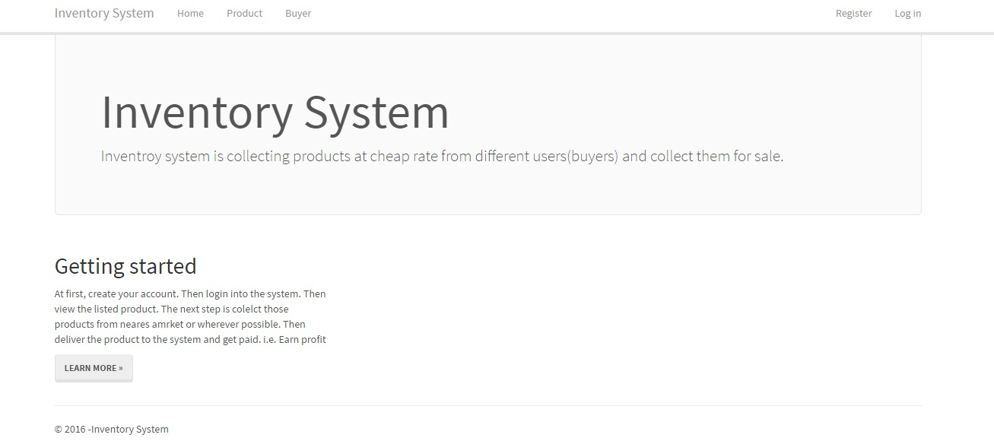

**Figure 1. Tabs on Inventory web system home page**

**3.3 Changing User ID and Password**

User ID and password can be changed only by the registered user.

**3.4 Exit System**

The inventory web system can be closed by logging out of the account on the device.

**4.0 USING THE SYSTEM**

**4.0 USING THE SYSTEM**

This section provides a detailed description of system functions.

**4.1.1 Logging in to the system**

The inventory system is a web based application, helps the capitalist ‘s in operating their store’s online. First of all, to enter into the system user should login so that they can navigate through the system and check for their respective products.

**4.1.2 Login tab**

The login tab consists of two input fields containing information to login that matches in the database when the user registered previously. It needs email and the password (Figure 2) chosen by the user.

Email, password both are text input fields. When both these fields are entered by respective credential’s user can enter into the system by clicking on the log in button (Figure 2). There is also a check box named Remember me, this is for the user to store the password in the system cache so that users need not to provide a password for every login in their device.

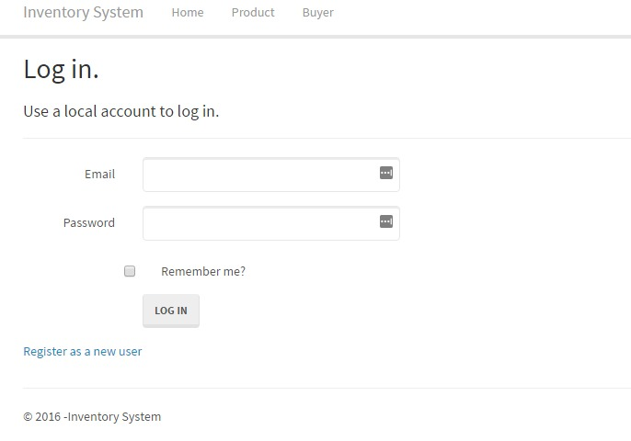

**Figure 2. Log in Tab of Inventory web system**

**4.1.3 Register tab**

If the user is new to the system and not registered, to navigate in the system, users should be registered. The register tab consists of three input fields, provide credential information to login so that data will be stored in the database, when a user registers. It needs email and the password (Figure 3) chosen by the user.

Email, password both are text input fields. When both these fields are entered by the respective credential user can register into the system by clicking on the register button (Figure 3). So now a user has registered, can login and use the system with ease.

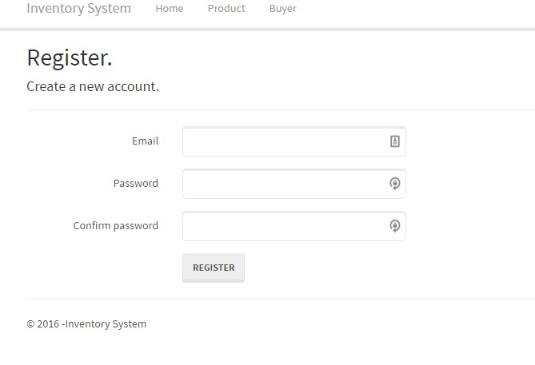

**Figure 3. Register Tab of Inventory web system**

**4.1.4 Product tab**

The product tab consists of eight input fields (Figure 4) containing details of the product to be bought or to be sold. Details such as name, type, code, size, color, quantity, and comment.

All the input fields are text fields except for the quantity field as it is numeric. The name field is for the name of the product; type, for the type of the product. Code, size, color fields are for unique code, dimensions (measures), the color of the product, respectively. Comments field is a text field where users can provide general comments and remarks about the product. The Save button is to save the product details.

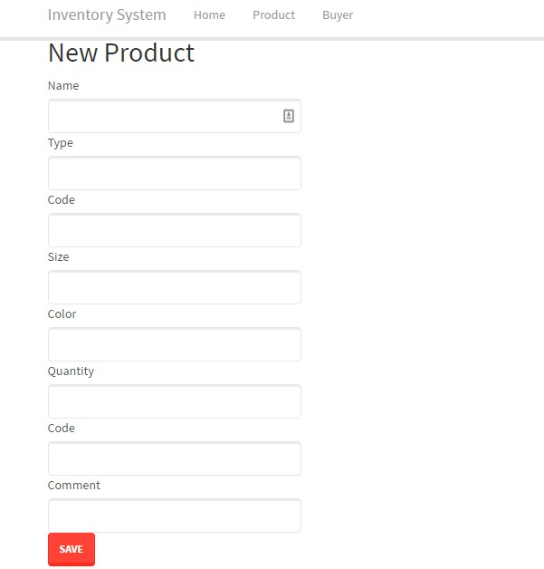

**Figure 4. Product Tab of Inventory web system**

**4.1.5 Buyer tab**

The buyer tab consists of eight input fields (Figure 5) containing details of the buyer, such as first name, middle name, last name, address, city, zip code, phone, email.

All the input fields are text fields except for the zip code and phone as they are numeric. First name, last name, middle name fields are the for the first name, last name and middle name of the buyer. Address, city, zip code fields are the address, city, zip code of the city of the buyer respectively. Phone field is for the contact number of the buyer. The email field is the email address of the buyer to send the notifications like status.

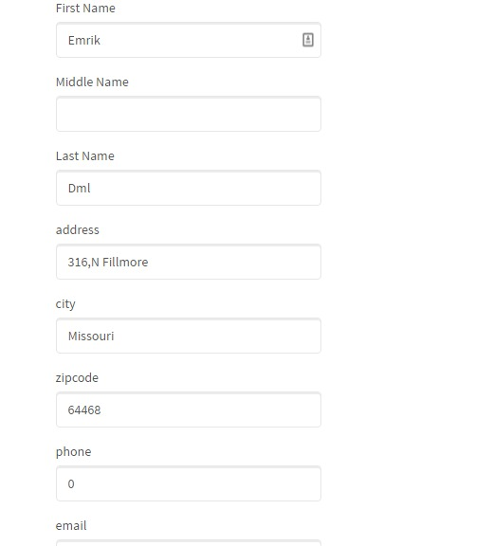

**Figure 5. Buyer Tab of Inventory web system**

**4.1.6 Home tab**

Home tab is to navigate back to the home page of the system when the user wants to start from the beginning.

**4.1.7 Inventory system tab**

The inventory system tab provides details of the inventory web system application process.

**4.2 Special Instructions for Error Correction**

In case if GPS cannot be used to work on the system, you may want to use an external GPS device and input parameters manually. Similarly, in case of inaccuracy of GPS data you may want to use external GPS device. Note that refreshing the network changes account’s in increase of accuracy.

**5.0 REPORTING**

**5.0 REPORTING**

The reporting section describes in what way information collected by the application is presented and how to access the information and the process to deliver the products.

**5.1 Report Capabilities**

Information about each buyer is created with a list (Figure 5) with seven columns such as first name, middle name, last name, verified, discount rate, address.

All the columns are text field except for the verified and discount rate are check box and numeric respectively. The list consists of the series of buyers’ information like first name, middle name, last name, address. The discount rate of the product and check box to check whether it is verified. To modify the information about the buyer’s in the list we have edit and delete options to edit the buyer info or to delete the buyer row and details option to view the details.

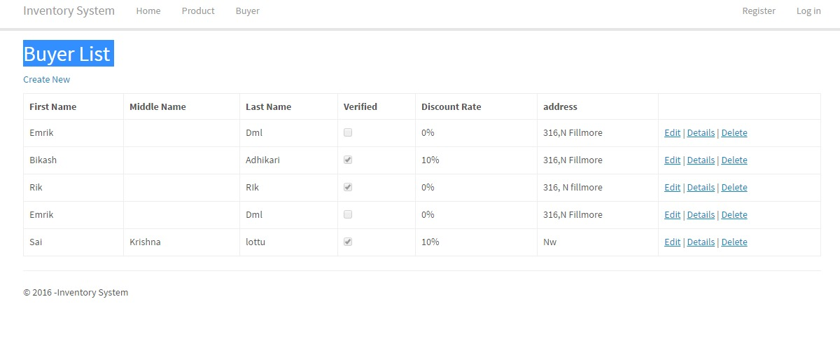

**Figure 6. Buyer List of Inventory web system**

**5.2 Report Procedures**

The report described about buyer’s can be accessed by the buyer’s list by navigating into the buyer’s bar of the system. When the buyer’s list is generated the labels were given with their respective details and packages are shipped, seller examines the package and proceeds accordingly to the payment system. You have to log in to access the information. User name and password are the same as used in the application. Each user can see only information about own. Data collected using the application is saved in database.